Sketching Polynomials

1. Sketch the graph, clearly identifying the x-intercepts.

a) 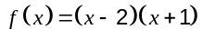 | b) 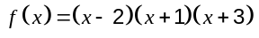 | c) 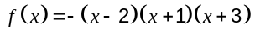
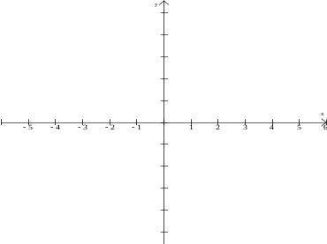
Degree of the function: ______  x-intercepts: _______________  y – intercept: __________ | Degree of the function: ______  x-intercepts: ___________  y – intercept: __________ | Degree of the function: ______  x-intercepts: ___________  y – intercept: __________
d) 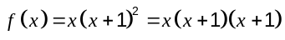 | e) 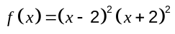 | f) 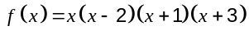
Degree of the function: ______  x-intercepts: ___________  y – intercept: __________ | Degree of the function: ______  x-intercepts: ___________  y – intercept: __________ | Degree of the function: ______  x-intercepts: ___________  y – intercept: __________
g) 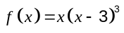 | h) 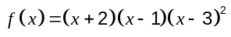 | i) 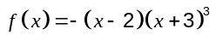
Degree of the function: ______  x-intercepts: ___________  y – intercept: __________ | Degree of the function: ______  x-intercepts: ___________  y – intercept: __________ | Degree of the function: ______  x-intercepts: ___________  y – intercept: __________

2. Determine an equation for a function with the following characteristics:

a) Degree 3, a root at 4 (order 2), a root at –3 ____________________________

b) Degree 4, an root at 2 (order 3), a root at 5 ____________________________

c) Degree 3, roots at 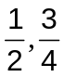, –1 _____________________________

d) Degree 3, starting in quadrant 2, ending in quadrant 4, root at –2 and a root
at 3 (order 2) _______________________

- Degree 4, starting in quadrant 3, ending in quadrant 4, roots
at –10 (order 2) and 10 (order 2) _________________________

Determine the equation for each polynomial function.
a) 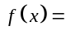 | b) | c)
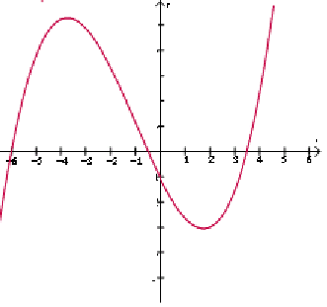 | 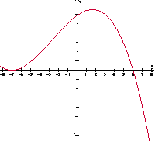 | 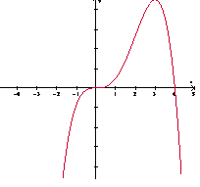
d) | e) | f)
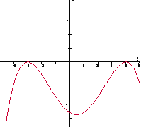 | 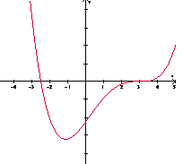 | 

